**Forecasting the Electricity Consumption of a City by Transfer Analysis**

Time Series Analysis and Forecasting

Arvind Ramkumar

Graduate Student – Industrial Engineering

Data Analyst | Data Engineer

**Table of Contents**

**Holt Winters Model ………………………. 3**

**Seasonal ARIMA for Temperature ………………………. 4**

**Spectral Analysis ………………………. 8**

**Transfer Function Model ………………………. 9**

**Forecasting Electricity Consumption ………………………. 14**

**Holt Winter Forecasting**

Holt Winters are used to make short term exponential forecasting by using Multiplicative or Additive Model. One of the things with the Holt- Winters Method is to choose the Best Exponential Smoothing Parameters.

There are three Exponential Smoothing Parameters are

* Overall Smoothing – 𝛼
* Smoothing of Trend Factor – β
* Smoothing of Seasonal Index – 𝛾

The Best Smoothing Parameters are obtained from R by using,

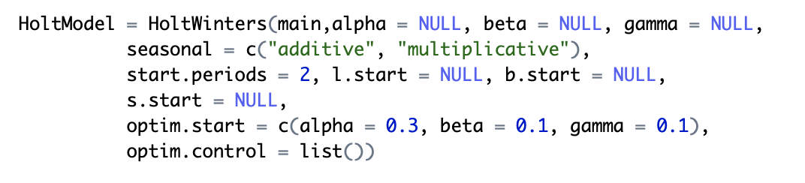

The Obtained Optimal Values for the Exponential Smoothing Parameters are given below. And it is an additive model.

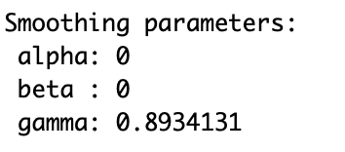

To examine the adequacy of the model developed, we check the residuals, and none of the residuals should lie beyond the confidence band.

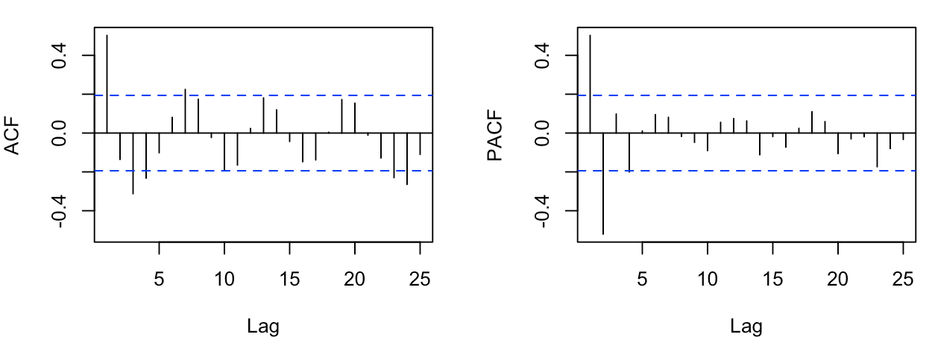

Figure 1 : ACF and PACF of Residuals

Except for a couple of Lags, almost every lag seems to lie within the confidence band. So, the model is adequate.

Measure of Error

MAPE and MSE was the error measure that was used to validate the model

* MAPE – 4.6784
* MAD – 0.9876
* RMSE – 1.0235

**Developing Seasonal ARIMA for Temperature**

The first step in the model building is to look at the Time series plot to analyze the Stationarity of the data.



Figure 2 : Time Series Plot of Temperature

The Time Series Plot gives us the evidence that the there is no variation in Mean of the data. So, the model is Stationary. Because of this there is no necessity for Non-Seasonal Differencing.

Next, we analyze the ACF and PACF of Temperature to get an idea of the AR and MA component and to have an understanding about the Seasonality.



Figure 3 : ACF and PACF Plot of Temperature

Now when we examine the ACF and PACF plot, we see that there is a significant presence of AR (Exponential Decay in ACF Plot) and the presence of MA (Exponential decay in PACF plot).

But with the mix of both AR and MA along with the seasonal component it is difficult to estimate the candidate models directly. So, we make use of R to obtain the candidate models with the help of AIC Criteria.

The candidate models obtained from R is given below

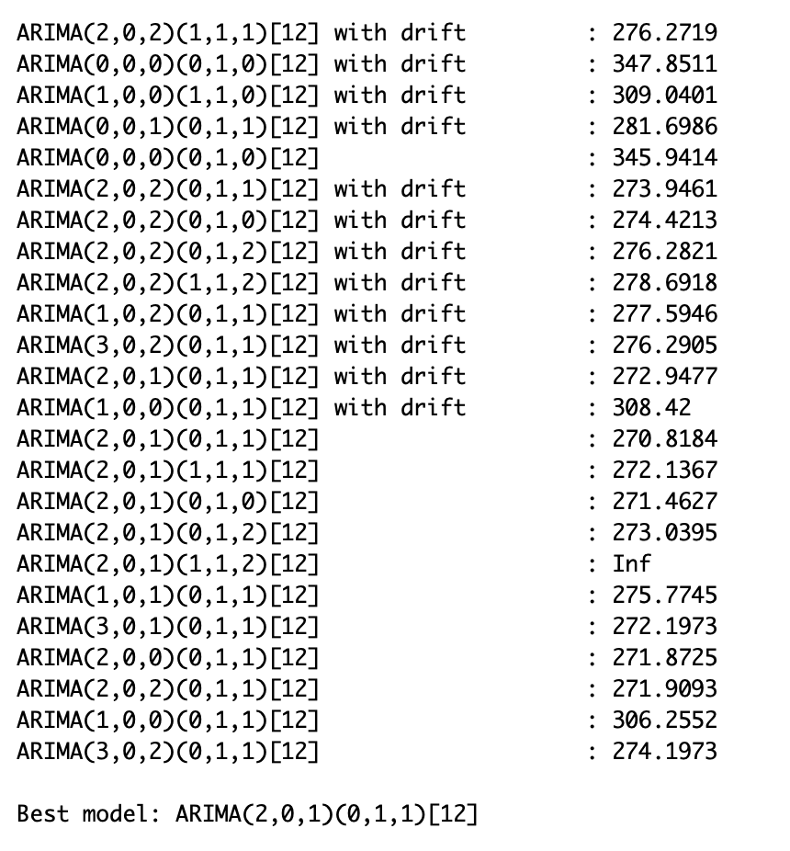

Out of all these models, we choose a few candidate models based on the inference from ACF and PACF plot and the AIC value. We will choose our best model based on comparing a few error measures and AIC values. The comparison is given below.

Table 1 : Comparison of Error Measures for Candidate Models

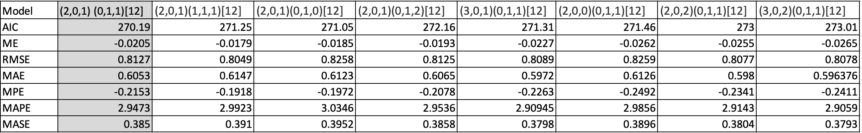

We have compared the model based on the Error measures including Mean Error, RMSE, MAPE etc. On comparing with these, the Optimal R and the ACF and PACF, we choose the best model for Temperature to be ARIMA (2,0,1) (0,1,1) [12].

Forecasting using ARIMA (2,0,1) (0,1,1) [12]

The model is fitted and the coefficients of the ARMA components are given below. These values of coefficient are used to obtain the forecast of the models.

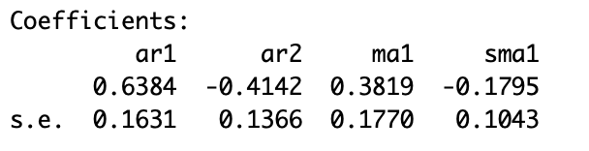

The Forecast value obtained by using the ARIMA model for the Next Six Period (Between July 2006 and December 2006) is given below

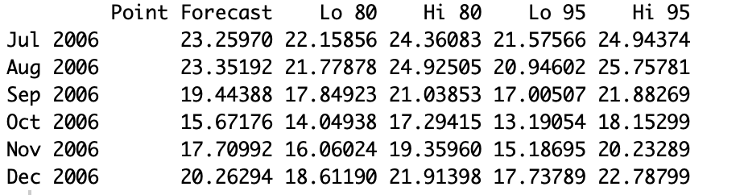

The Forecast graph of the model is given below.



Figure 4 : Forecast Plot for Six Periods Using ARIMA (2,0,1) (0,1,1) [12]

We will also look at the ACF and PACF of the residuals to check the adequacy of the model.

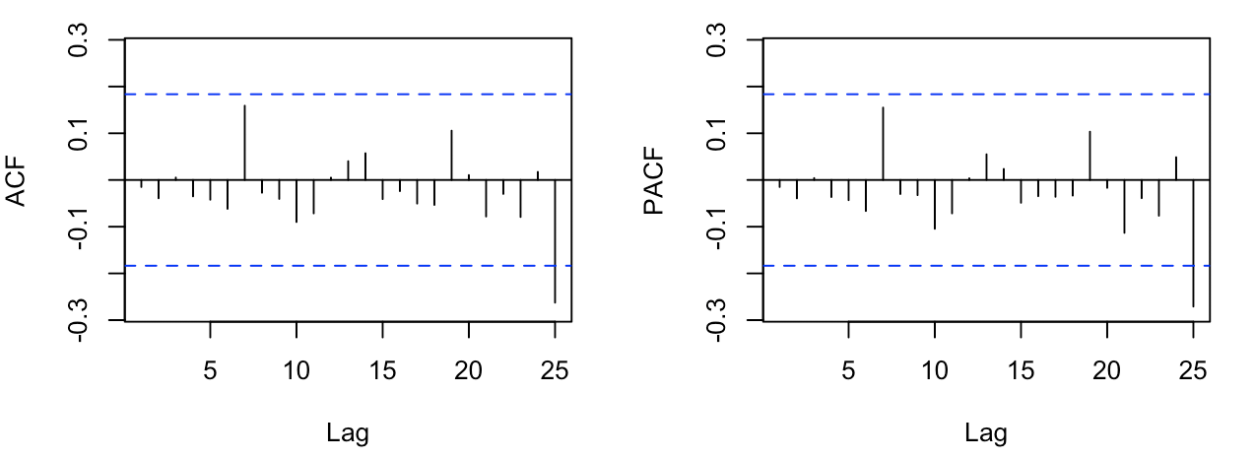

Figure 5 : ACF and PACF of the Residuals of Model ARIMA (2,0,1) (0,1,1) [12]

Almost every lag lies within the confidence band. So, the model is adequate.

Compare Seasonal ARIMA with Holt Winters

Table 2 : Comparing Seasonal ARIMA and Holt Winters Method

|  |  |  |
| --- | --- | --- |
|  | Seasonal ARIMA | Holt Winters Method |
| MAPE | 2.9473 | 4.6784 |
| MAD | 0.7651 | 0.9876 |
| RMSE | 0.8127 | 1.0235 |

So, from the above table it is quite evident that Seasonal ARIMA model performs much better than the Holt Winters Method.

**Spectral Analysis of Temperature**

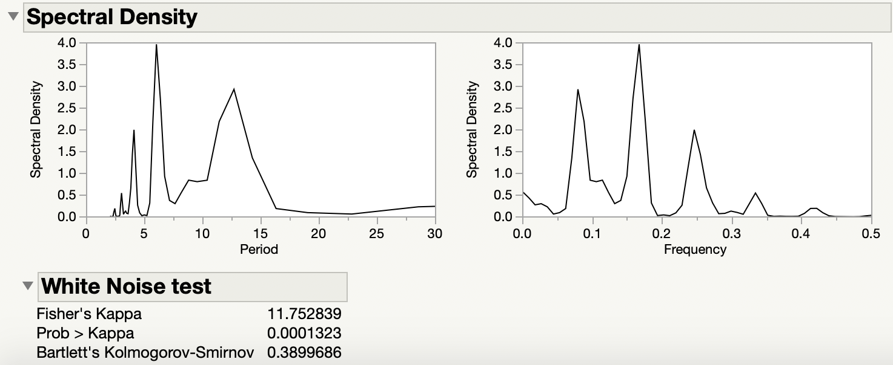

Figure 6 : Spectral Analysis of Temperature

Spectral Analysis is used to convert the model is time domain to frequency domain. The spectral density is used to locate the hidden seasonality in the model.

From the spectral density graph given above, we see that there is a sharp spike when the period is 6. So, we could say that there is a hidden seasonality with time period 6.

Also, examining the Frequency vs Spectral Density Plot, there is a evident spike when the frequency is roughly around 0.2. The inverse of the frequency is the time period. So, the spiked frequency roughly translates to the time period 6. This is another evidence that there could be a hidden seasonality in time period 6.

White Noise Test

Fisher’s Kappa

H0: Values in the series are drawn from a normal distribution with variance 1

H1: Series is a Periodic Component.

Since the Fisher’s Kappa has a high value and the Prob. > Kappa is much lesser than the significance level of 𝛼, it is an evidence against the null hypothesis. So,we can say that the series has a periodic Component.

So, it is now quite evident that the model has seasonality.

**Transfer Function Model**

Out of All the Models we have built, we choose the prediction of Temperature obtained from Seasonal ARIMA (2,0,1) (0,1,1) [12]. We use this Temperature Prediction, build a transfer Function Model and obtain the prediction for the Electricity Consumption.

The Prediction for Temperature is

Table 3 : Temperature Prediction obtained from ARIMA

|  |  |
| --- | --- |
| Time Period | Temperature |
| July 2006 | 23.25976 |
| August 2006 | 23.35192 |
| September 2006 | 19.44388 |
| October 2006 | 15.67176 |
| November 2006 | 17.70992 |
| December 2006 | 20.26294 |

Keeping this model of ARIMA, we will develop a Transfer function model to predict the Electricity Consumption. The Procedure for developing a Transfer Function model is given below. We proceed with the fact that the Input Series is defined by ARIMA (2,0,1) (0,1,1) [12].

Pre - whitening

Initially we can observe that the Input and the Output has correlation and the past input affect the future forecast. So, we Pre -Whiten the model to obtain the CCF plot. This CCF plot is used to estimate the possible values for the parameter b, r, s.

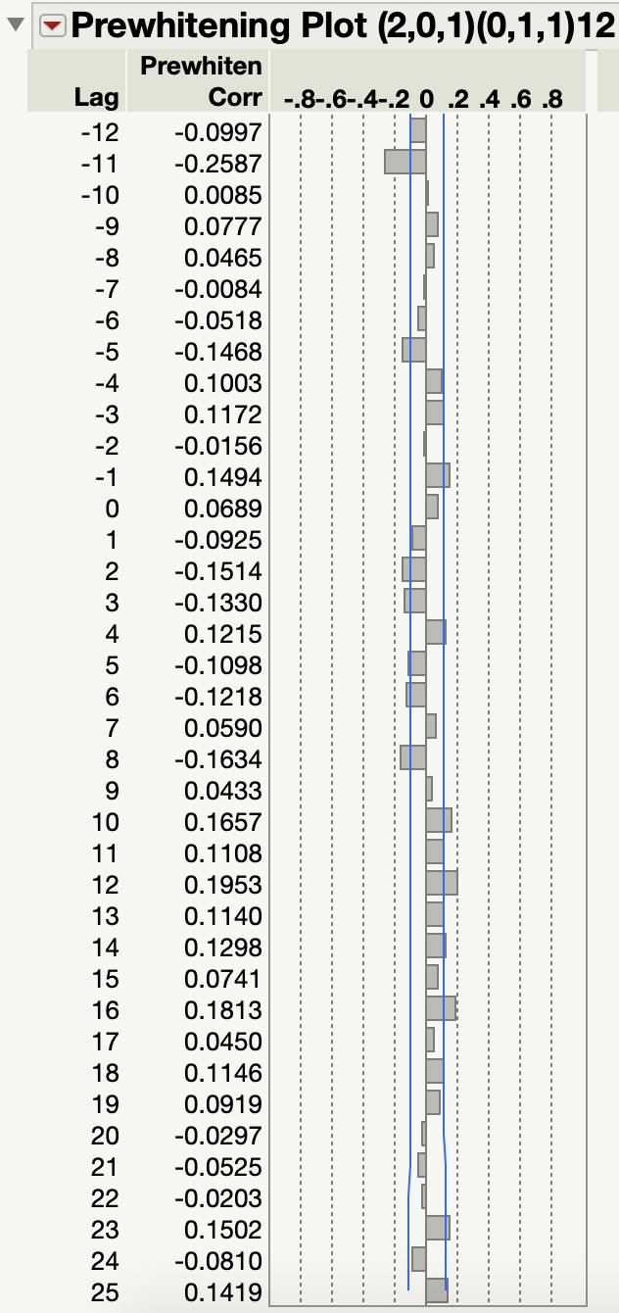

Figure 7 : CCF Plot After Pre-whitening

Estimating b

The parameter b gives us the information about the delay. The First significant Correlation after lag zero gives the estimate of the parameters. Clearly here, b = 2.

Estimating r

The parameters r gives us information similar to AR component. It is defined by the presence of Exponential or Damped Sinusoidal Wave after the lag.

Estimating s

The parameter s gives us information similar to the MA component. It is defined by the presence of pattern less spikes after the delay.

But here the model seems to be complex, so it is kind of not possible to get the estimate of r and s. So, we fit various models using different values of r and s and choose the best model based on the MAPE and other such factors. The combination of the models to be tested are

b = 2, s = 0, r = 0 – Transfer Function 1

b = 2, s = 0, r = 1 – Transfer Function 2

b = 2, s = 0, r = 2 – Transfer Function 3

b = 2, s = 1, r = 0 – Transfer Function 4

b = 2, s = 1, r = 1 – Transfer Function 5

b = 2, s = 1, r = 2 – Transfer Function 6

b = 2, s = 2, r = 0 – Transfer Function 7

b = 2, s = 2, r = 1 – Transfer Function 8

b = 2, s = 2, r = 2 – Transfer Function 9

Also, since from the CCF Plot we see that there could be higher order s and r also. So, we test for those also.

b = 2, s = 3, r = 0 – Transfer Function 10

b = 2, s = 3, r = 1 – Transfer Function 11

b = 2, s = 3, r = 2 – Transfer Function 12

b = 2, s = 4, r = 0 – Transfer Function 13

b = 2, s = 4, r = 1 – Transfer Function 14

b = 2, s = 4, r = 2 – Transfer Function 15

b = 2, s = 0, r = 4 – Transfer Function 16

b = 2, s = 1, r = 4 – Transfer Function 17

b = 2, s = 2, r = 4 – Transfer Function 18

b = 2, s = 3, r = 4 – Transfer Function 19

b = 2, s = 4, r = 4 – Transfer Function 20

The models are fitted and the comparison of them is given below.

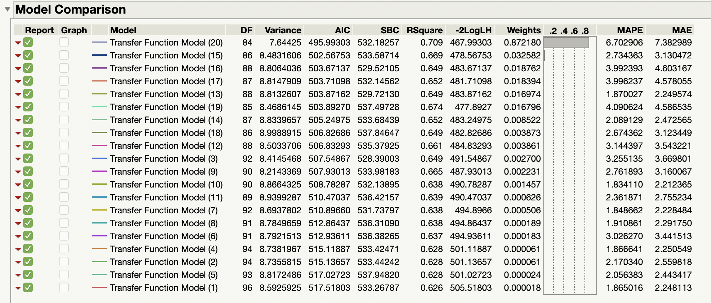

Figure 8 : Comparison of different Transfer Function

Now, comparing all the above models, based on the use of AIC and MAPE, we choose the best model to obtain the estimate of the parameters. The Candidate Models and their comparison is given below.

Table 4 : Comparison of the candidate transfer function models

|  |  |  |
| --- | --- | --- |
| TF Models | MAPE | AIC |
| TF Model 1 | 1.865 | 505.51 |
| TF Model 4 | 1.866 | 501.11 |
| TF Model 7 | 1.849 | 494.89 |
| TF Model 8 | 1.911 | 494.86 |
| TF Model 10 | 1.834 | 490.78 |
| TF Model 13 | 1.870 | 483.87 |

From the above table, we see that we could either pick Transfer Function Model 10 or Transfer Function Model 13 for the study. Further on to decide the Best TF model out of these two, we look at their ACF and PACF of their residuals.

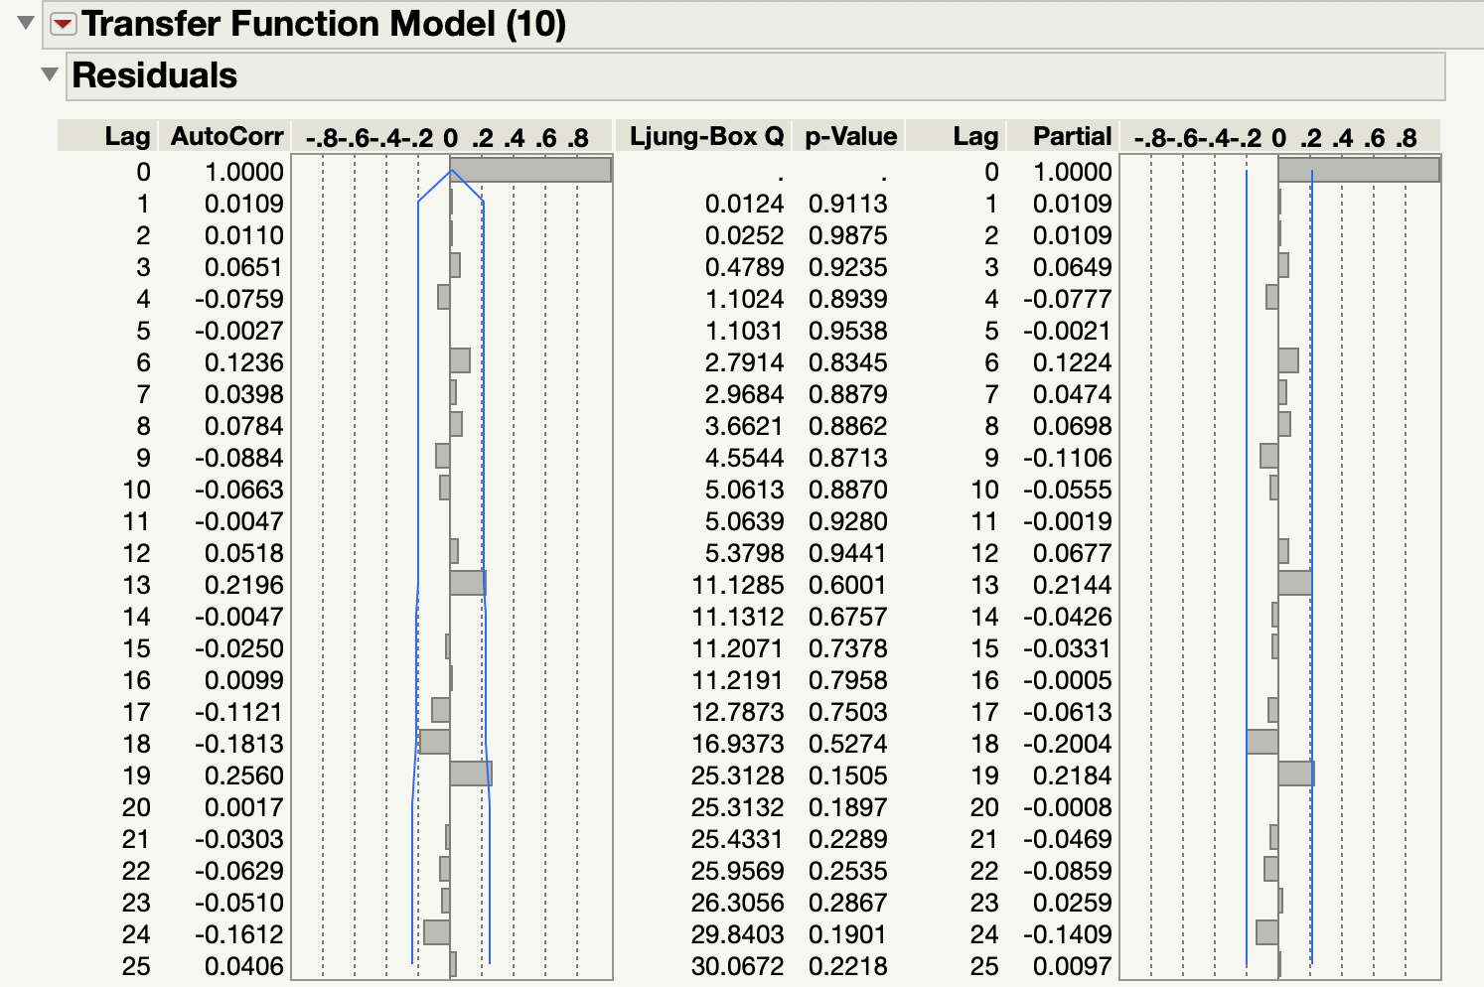

Figure 9 : ACF and PACF Plot of TF Model 10

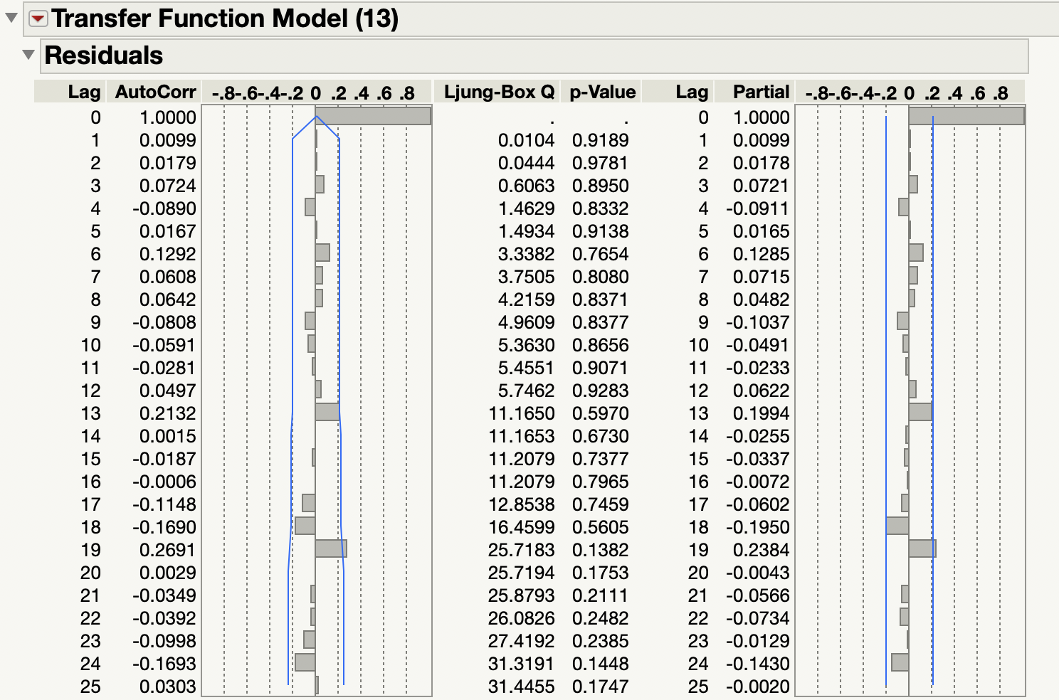

Figure 10 : ACF and PACF Plot of TF Model 13

Based on the ACF and PACF of the models, both the model seems to be significant. But there is an untold rule that it is always better to choose a simpler model. So, choosing TF Model 10 over TF Model 13 will make sense.

The Parameter Estimates are

* b – 2
* s – 3
* r – 0

The Final Model to be fit for the Transfer Function Would have the ARIMA Order to be (2, 0, 1) (0, 1, 1) [12] and (b, r, s) = (2, 3, 0)

TRANSFER FUNCTION – (2, 0, 1) (0, 1, 1) [12] and (b, r, s) = (2, 3, 0)

The Transfer Equation is given below

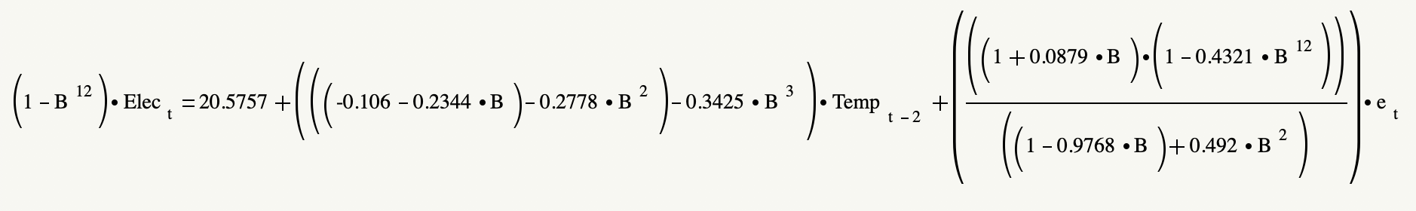

Figure 11 : Transfer Function Equation for Model ARIMA (2, 0, 1) (0, 1, 1) [12] and (b, r, s) = (2, 0, 3)

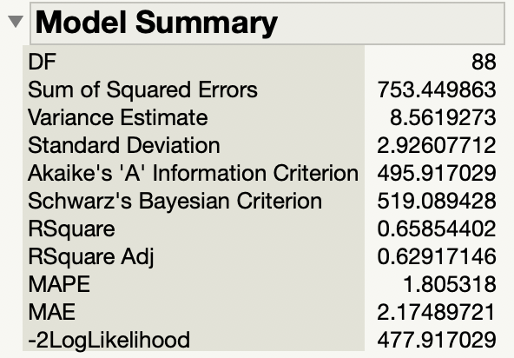

Figure 12 : Summary of the Transfer Function Model

Residual Analysis – Model Adequacy

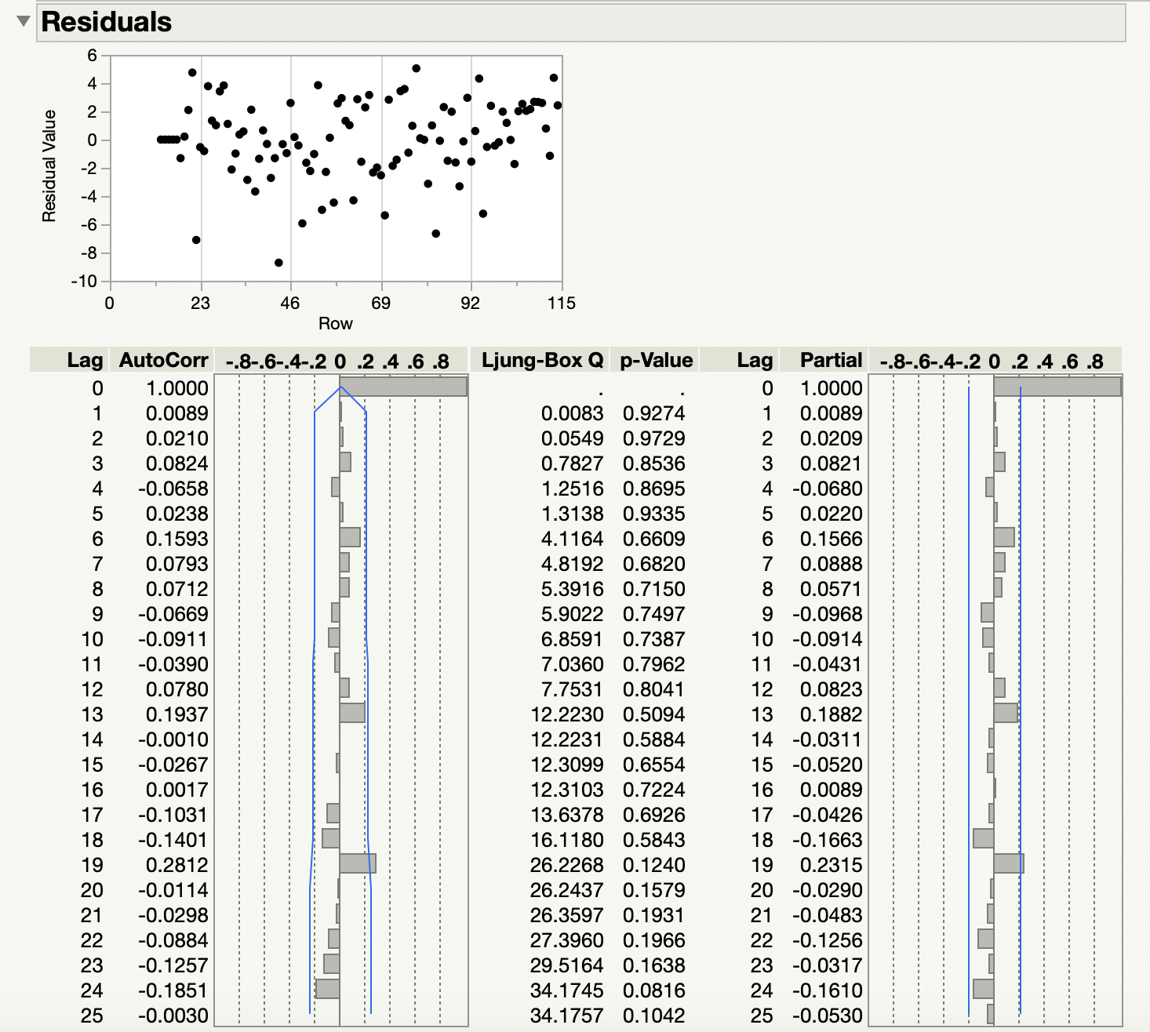

Figure 13 : Residual Analysis for the Transfer Function Model

Based on the residual analysis, we can see that every lag lie within the confidence band and the residual plots doesn’t seems to follow any pattern So, the model is adequate.

**FORECASTING**

Forecasting Electricity Using TF assuming causal relationship

The Forecast for the next 6 time periods is given below.

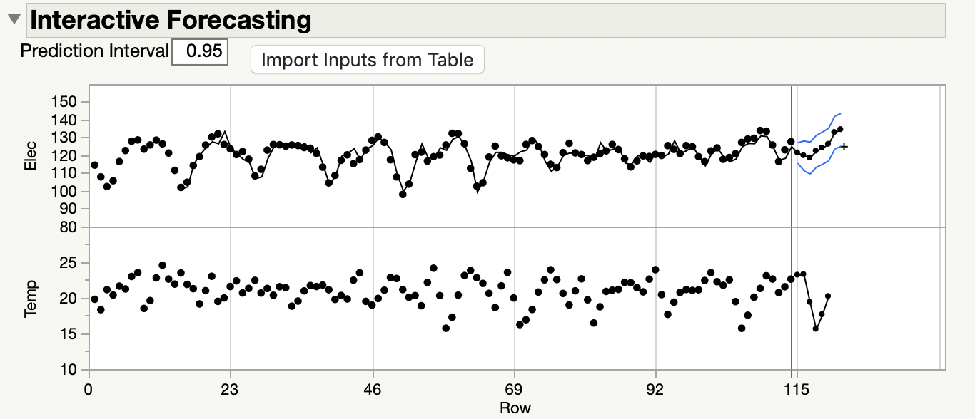

Figure 14 : Forecast Graph for the Model

Forecast

Table 5 : Forecast between July 2006 and December 2006

|  |  |  |
| --- | --- | --- |
| Month | Temperature | Electricity |
| Jul-06 | 23.259 | 121.7061 |
| Aug-06 | 23.352 | 120.1238 |
| Sep-06 | 19.443 | 118.8688 |
| Oct-06 | 15.67 | 122.6741 |
| Nov-06 | 17.71 | 124.4258 |
| Dec-06 | 20.262 | 126.4937 |

The Future Streamflow of both monthly Maximum Temperature and Electricity Consumption is Predicted for months July 2006 and December 2006.

Forecasting Electricity as a Univariate Time Series

But when we look at the Plot between Electricity and Temperature, we see that there is no significant correlation between them. So, treating the electricity as an independent time variable, and develop a Seasonal ARIMA to predict the Electricity will also work. But first, we will look at the Plot between Electricity and Temperature

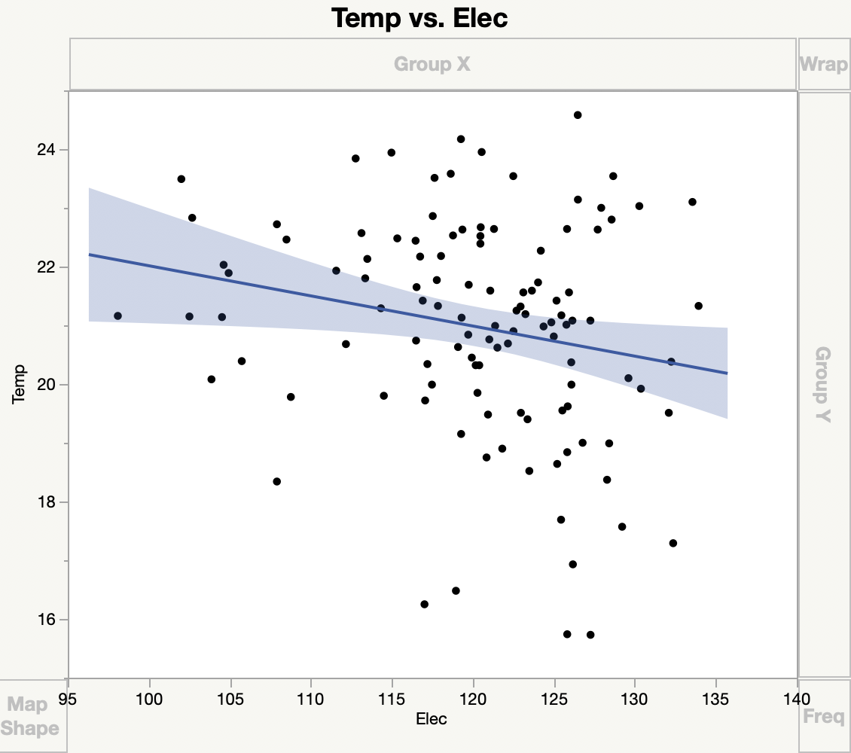

Figure 15 : Graph defining the relation between Temperature and Electricity

**Developing Seasonal ARIMA for Electricity**

The first step in the model building is to look at the Time series plot to analyze the Stationarity of the data.



Figure 16 : Time Series Plot of Electricity

The Time Series Plot gives us the evidence that there could variation in Mean of the data. So, the model might not be Stationary. The Seasonal Difference might be required.

Next, we analyze the ACF and PACF of Temperature to get an idea of the AR and MA component and to have an understanding about the Seasonality.





Figure 17 : ACF and PACF Plot of Temperature

Now when we examine the ACF and PACF plot, we see that there is a significant presence of AR (Exponential Decay in ACF Plot) and the presence of MA (Exponential decay in PACF plot). But with the mix of both AR and MA along with the seasonal component it is difficult to estimate the candidate models directly. So, we make use of R to obtain the candidate models with the help of AIC Criteria.

The candidate models obtained from R is given below

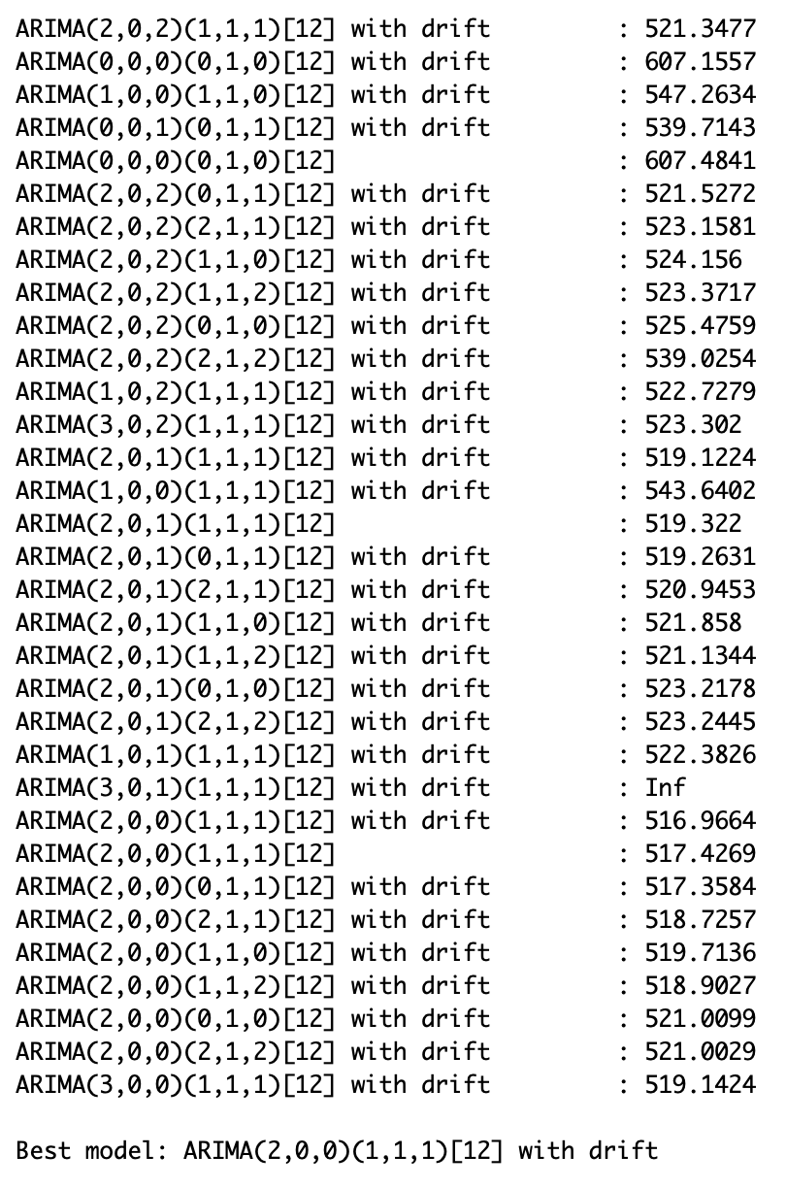

Out of all these models, we choose a few candidate models based on the inference from ACF and PACF plot and the AIC value. We will choose our best model based on comparing a few error measures and AIC values. The comparison is given below.

Table 6 : Comparison of Error Measures for Candidate Models

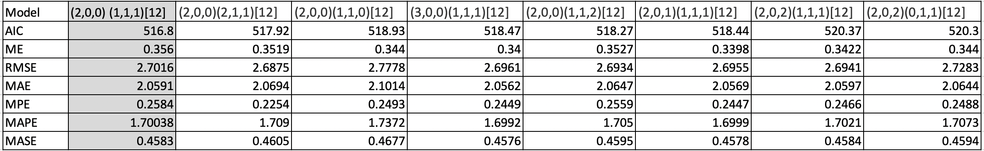

We have compared the model based on the Error measures including Mean Error, RMSE, MAPE etc. On comparing with these, the Optimal R and the ACF and PACF, we choose the best model for Temperature to be ARIMA (2,0,0) (1,1,1) [12].

Forecasting using ARIMA (2,0,0) (1,1,1) [12]

The model is fitted and the coefficients of the ARMA components are given below. These values of coefficient are used to obtain the forecast of the models.

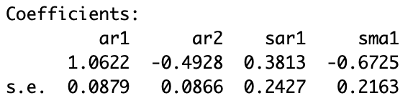

The Forecast value obtained by using the ARIMA model for the Next Six Period (Between July 2006 and December 2006) is given below

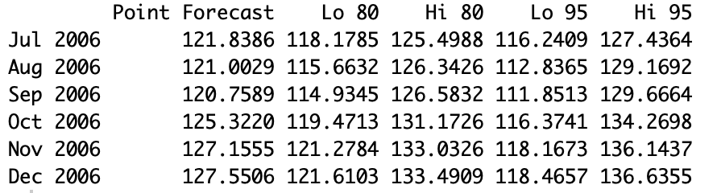

The Forecast graph of the model is given below.



Figure 18 : Forecast Plot for Six Periods Using ARIMA (2,0,1) (0,1,1) [12]

We will also look at the ACF and PACF of the residuals to check the adequacy of the model.

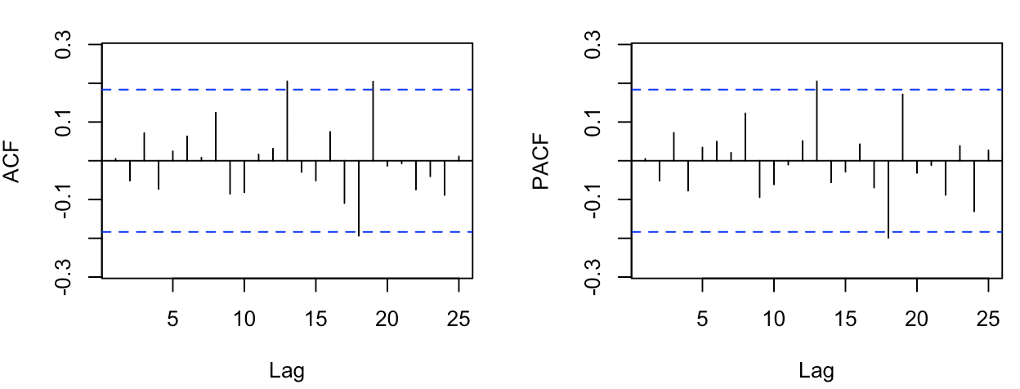

Figure 19 : ACF and PACF of the Residuals of Model ARIMA (2,0,0) (1,1,1) [12]

Almost every lag lies within the confidence band. So, the model is adequate.

Thus, the forecast of the Electricity for the Months between July 2006 and December 2006, treating the Electricity as an independent time series is given below.

Table 7 : Forecast of Electricity Consumption

|  |  |
| --- | --- |
| Time Period | Electricity |
| July 2006 | 121.8386 |
| August 2006 | 121.0029 |
| September 2006 | 120.7589 |
| October 2006 | 125.3220 |
| November 2006 | 127.1555 |
| December 2006 | 127.5506 |